GPHY 101 : Human Geography
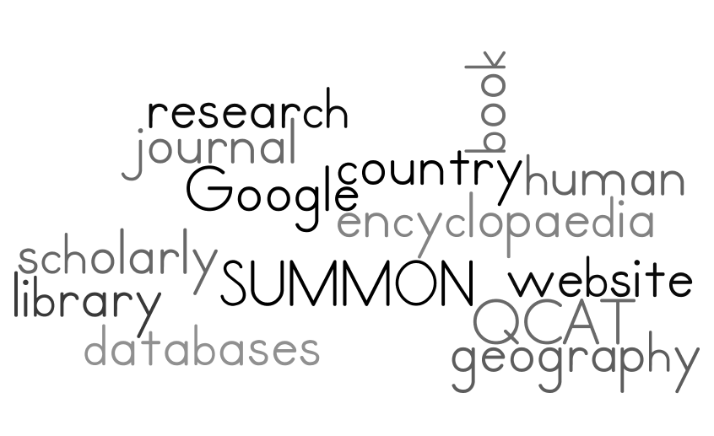
- Before you begin…
Research by subject – Subject guide to help you begin your research
- Go to the library homepage http://library.queensu.ca
- Select “Social Sciences” under the Research by Subject link
- Select “Geography”

The information on this page will guide you with your research.
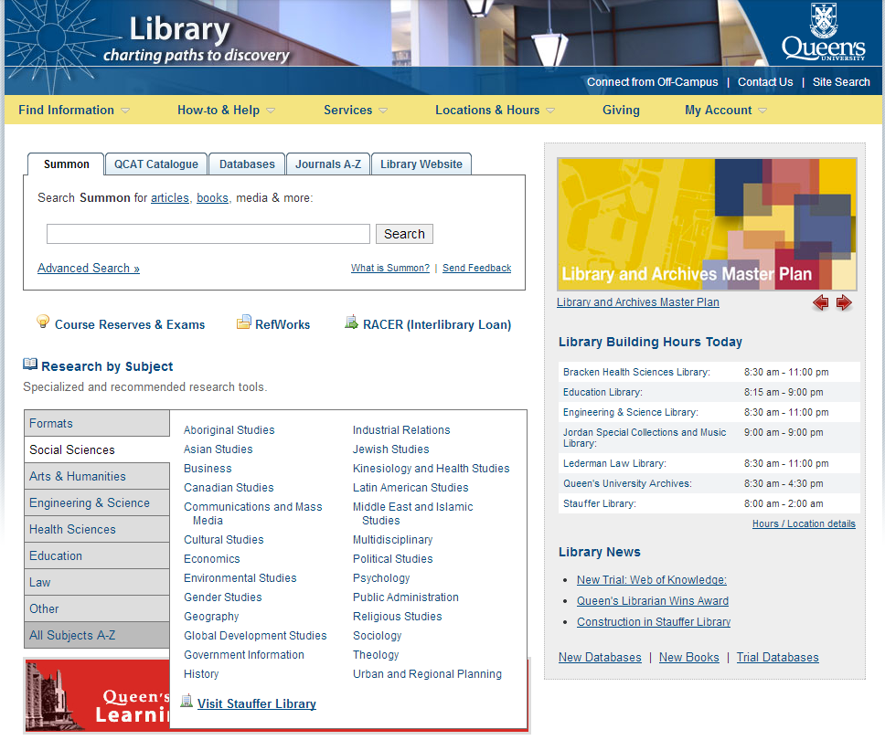

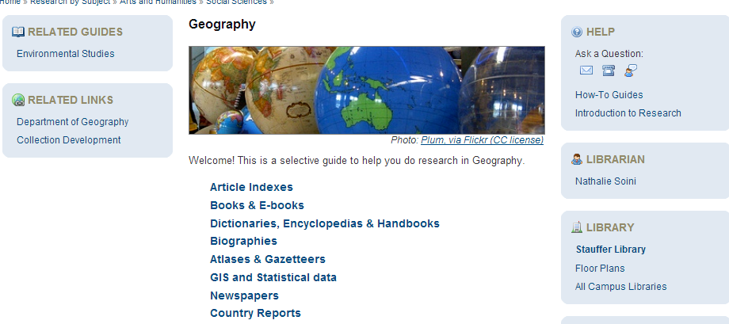
Start your research here
- Library Catalogue (QCAT)
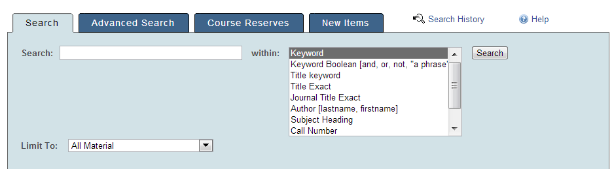

Search for books:
Steps for finding books:
- Construct keyword search.
- Open record, record call number.
- Check the subject headings by clicking on Full Record.
- Search again with other words if necessary.

Keyword (Boolean) Search:
A keyword search looks for words located anywhere in the record.

Points to remember:
- Use and to combine search terms.
For example: Globalization and Namibia
- Use or to group alternate terms to expand your search
For example: (Namibia or “southern Africa”) and (core or peripheral)
- Use not to exclude word from your search
For example: (Africa not namibia)
- Search phrases by using quotations around words.
For example: “southern Africa”
- Use ? for plural forms and variant word endings
For example: identit?
The question mark represents: identity, identities, identität, identité, identités, etc.
- Group search terms by using parentheses
For example: (Namibia or “southern Africa”)

- Finding scholarly articles
START WITH A MULTI-DISCIPLINARY DATABASE, SUCH AS:
Google Scholar : A good starting point…but never search only Google Scholar for journal articles.
Academic Search Complete: Indexes more than 10,900 publications including peer‐reviewed journals, popular magazines, conference proceedings, monographs and reports.
Scholar’s Portal Journals: The content in Scholars Portal is a multi-disciplinary database of peer reviewed academic literature.
Summon: Queen’s Library search engine that provides credible, relevance ranked results from the library’s online and print collections in a single search (like Google Scholar).
It contains everything found in the traditional QCAT Library Catalogue, plus millions of full-text articles available from the Library.
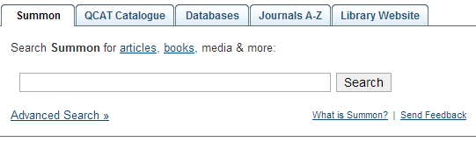
SUMMON TIPS:

- When searching with OR, make sure your OR is capitalized (the same applies to NOT)
- You can “Refine your search” in the Left Navigation bar
- You may do an “advanced search”
- You may save your search results and email them

AND THEN, MOVE ON TO A DISCIPLINE SPECIFIC DATABASE:
A few suggestions are listed below. Consult the Research by Subject ... Geography guide for more ideas. If your research is in a more specific area like Gender Studies, Global Development Studies or Economics, etc. you might want to consult the subject guide for a database relevant to that discipline. Remember to look at the literature with a Geography ‘lens’.
GEOBASE A comprehensive, international and interdisciplinary database for the fields of physical and human geography, including geology, ecology, mineralogy, oceanography, environmental issue, Third World studies....
IBSS International Bibliography of the Social Sciences Social science and interdisciplinary research with international coverage
PAIS Comprehensive, international index to the literature of public and social policy, and to the social sciences in general. Covers journal articles (scholarly and popular), books, government documents (emphasis on Canada, USA, UN), statistical compilations, committee reports (private and public), and directories.
Social Sciences @ Proquest Covers over 25 Social Sciences databases in one database.
Principles for searching electronic indexes:
- Identify Keywords.
For example: globalization, Namibia, Africa, southern, country, core, peripheral, semiperipheral,etc.
- Find out if a phrase needs quotations (depends on the database) (if in doubt, click on the HELP button to find out how to effectively search a database).
- Find out how to get different word endings. For example, is * (an asterix) used for different word endings or is it ? (a question mark)
- Look for subject headings or descriptors in a useful record for more keyword ideas.
- Selecting the Get it @Queen’s button does NOT imply that the article will be online/fulltext

Points to remember:
- Look for the year you want and record its location and call number. Journals can be on online in fulltext, paper or microfilm. Current print journals (periodicals) and Bound journals are on the 2nd floor of Stauffer Library.
- Do not search QCAT by journal author or article title. Only the journal title is listed in QCAT.
- To improve a search, check the descriptors, controlled vocabulary, or subject headings in the record

- Citing in APA Style and Annotated Bibliographies

To find guides (in print and online) for APA Style, go to:
- http://library.queensu.ca/help/cite-sources#apa
- http://sass.queensu.ca/writingcentre/wp-content/uploads/sites/3/2013/06/APA.pdf

What is an annotated bibliography? It is a bibliography that not only lists the sources you’ve discovered to write your essay but also briefly comments on the content, value, and relevancy of those sources. From http://www.queensu.ca/writingcentre/handouts/Disciplines-AnnotatedBibliography.pdf 31/01/2012).

Use RefWorks or another citation manager to organize your research. Create your account and organize your citations.

- Google, Google Scholar, and more
There are no uniform standards on the Internet. Approach the information on the Internet with caution. Always evaluate the accuracy and quality of the information you find on the Internet. When you are searching YouTube, Google and Wikipedia, etc. use the following criteria:

Web evaluation criteria:
Authority – author(s)’s credentials & host site
Purpose – inform, persuade, relevance
Coverage – depth of content, bias
Currency – updated frequently, links maintained
Recognition – awards, reviews, links from other sites

- GOVERNMENT INFORMATION – FEDERAL, PROVINCIAL, LOCAL, INTERNATIONAL
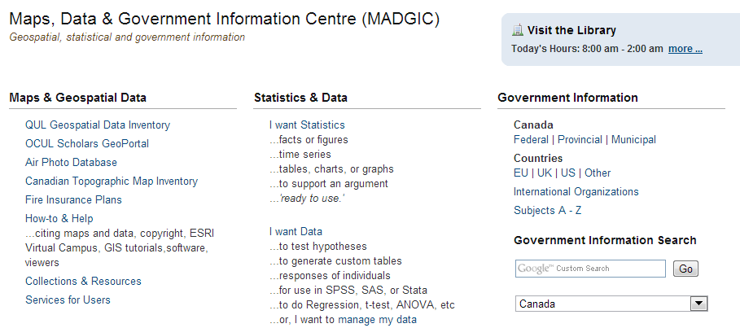
Custom Google searches from the Queen’s Library Government Documents page

- Some government publications are scholarly & authoritative; some not. How can you distinguish this? (see #5 above)
- Search for only Federal or Provincial or Municipal publications.
- Search for only IGO publications like the World Bank, United Nations, World Health Organization, etc. or only NGO publications like Human Rights Watch, The Red Cross, World Water Council, etc.

THANK YOU!

